Sale of high-rise apartment building in Brigittenau
Vienna, 8.8.2022 – S+B Gruppe AG has concluded the sale of another of its high-rise buildings, a residential tower in Vienna-Brigittenau, to Greystar Group. The two partners, who already worked together on the DC Tower 3 in Donau City, are adding an exciting 80-metre residential tower to the Viennese cityscape. The new high-rise will serve as the gateway to Vienna’s largest urban development area, the site of the former Nordwest Bahnhof.
The residential tower is being developed at Dresdnerstraße 90 in Brigittenau (the 20th district of Vienna) and will create high-quality living space: 119 serviced units at the base and 265 privately financed rental units with 1–4 rooms on the upper floors. All units are equipped with private open spaces (loggias, balconies) with panoramic views. On the 5th floor, on the roof of the base area, there will be a community, extensively planted roof terrace with a playground and community room. Residents will benefit from in-house parking, including e-charging stations for electric vehicles, numerous bicycle parking spaces (approx. 450) and other community areas.
A new cycle path and pedestrian access to public transport (Traisengasse commuter railway station, tram/bus station, Dresdner Straße underground station) are among the conveniences in this unique location. The building boasts low-energy design and is connected to the Vienna district heating network and the thermal component activation system can be used for both heating and cooling the building. The landscaping for the open spaces has also been designed to have a positive impact on the microclimate. A photovoltaic system will be installed on the roof of the building.
“We have already built DC Tower 3 for Greystar – and our fruitful collaboration has led to this new cooperation, with which we are entirely delighted”, says Ing. Wolfdieter Jarisch, CEO of S+B Gruppe AG. “The fact that one of the world’s largest property owners has once again chosen an S+B Gruppe project in Vienna offers further confirmation of the quality of planning and strategy of S+B Gruppe projects!” adds Oliver Zaininger, authorised signatory of S+B Gruppe AG.
The groundbreaking ceremony, which will take place in September, will bring the project partners together again.

Images:
The following images are approved for press use free of charge with appropriate credit
Link to the images

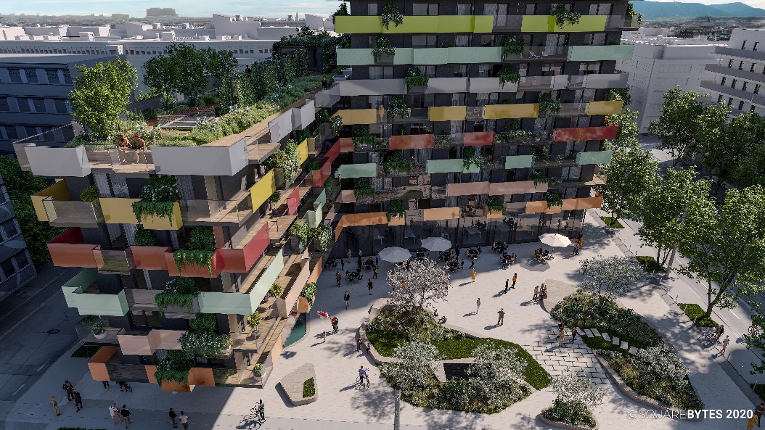

About S+B Gruppe:
S+B Gruppe AG, a privately-owned property developer with offices in Bucharest, Prague, Vienna and Warsaw, has been executing complex projects for over 35 years, acting as both an investor and general contractor. The team, headed by Managing Director Reinhard Schertler and Viennese general planner Alfred Michael Beck, together with the long-standing board members Wolfdieter Jarisch for Austria and Franz Paul Bauer for the CEE region and the two board members Edmund Völker and Wolfgang Eder for finances and accounting, specialises in the planning, construction management, commercial management and marketing of top-quality construction projects. A number of major developments are currently underway in Central and Eastern Europe. The combination of local on-site staff and international expertise is the key to S+B’s success. To date, the Group has invested more than EUR 6.2 billion in developing a total of 1,200,000 sqm of usable space.
www.sb-gruppe.at

About Greystar
Greystar is a leading, fully integrated real estate company offering expertise in investment management, development, and management of rental housing properties globally. Headquartered in Charleston, South Carolina, Greystar manages and operates approximately $221 billion of real estate in 224 markets globally including offices throughout North America, Europe, South America, and the Asia-Pacific region. Greystar is the largest operator of apartments in the United States, manages more than 754,000 units/beds, and has a robust institutional investment management platform with approximately $58.2 billion of assets under management, including $24 billion of development assets. Greystar was founded by Bob Faith in 1993 with the intent to become a provider of world-class service in the rental residential real estate business. To learn more, visit www.greystar.com.
For more information:
S+B Gruppe AG
Mag. Andrea Jarisch
Andrea.Jarisch@sb-gruppe.at
Tel: +43 1 7130650-5019

