AM SCHÖNEN PLATZ: BUILDING 7 AS FUTURE BNP Paribas REIM FUND ASSET

The two partners behind the Am schönen Platz residential project, S+B Gruppe AG and C&P Immobilien AG, have announced the sale of Building 7 to a BNP Paribas Real Estate Investment Management (BNP Paribas REIM) real estate special fund in a forward funding deal.

(Vienna, 27.07.2022) – The project partners, S+B Gruppe AG and C&P Immobilien AG, have announced that one of the 6 buildings they are developing on the site at Laxenburger Straße 151 in Vienna-Favoriten, the former home of the cosmetics company Beiersdorf, has been sold to PBP Paribas Real Estate Investment Management (BNP Paribas REIM). This section of the development, known as Building 7, features 8 floors (ground floor, 6 upper floors and a penthouse floor) and comprises a total of 55 apartments and 16 offices with a weighted floor area of approximately 3,500 sqm, plus 40 parking spaces in the underground car park. As a unique feature, the building’s office units can be accessed both from the residential areas and externally – a necessity for modern living. In total, the purchase comprises a net rental area of approx. 3,100 sqm.

On the site of the former Beiersdorf factory, a total of 6 residential buildings are scheduled for completion by 2024, with each building aimed at a different target group. While two sections of the building, earmarked for buy-to-let investors, have already been successfully placed on the market, Building 7 has now been acquired by BNP Paribas Real Estate Investment Management (BNP Paribas REIM) for its Diversipierre open-ended mutual property fund.

Am schönen Platz benefits from optimal transport connections (underground stations on the U1 line, numerous bus stops and easy vehicle access) and an exquisitely designed garden and outdoor facilities by André Heller.

The basement areas extend under the entire building footprint and are home to an underground car park, storage rooms and bicycle parking spaces. In addition to private open spaces such as balconies, loggias and terraces offering views as far as Schneeberg on clear days, the site also features a number of children’s playgrounds. Furthermore, greenhouses, Moroccan-inspired floor coverings, a fountain and green spaces with over 430 plant varieties (woody plants, perennials and grasses) are among the many highlights. Everyday shopping is as convenient as can be with a grocery retailer on the adjacent property, which is also home to a children’s daycare centre.

“With innovative planning and the unique design of the outdoor facilities in partnership with André Heller, we have been able to attract investors to districts of Vienna that are otherwise not at the top of their agenda. We are delighted that BNP Paribas REIM immediately recognised the property’s unique value”, explains Ing. Wolfdieter Jarisch, CEO of S+B Gruppe AG.

“In addition to their highly professional management expertise, we were immediately attracted to working on this project in partnership with S+B Gruppe AG because of the unique location in Favoriten. It was always our goal not only to meet the needs of the future tenants, but to exceed them – and that is precisely what we have achieved together”, says DI Cyrus Asreahan, Managing Director of C&P Immobilien Vienna.

“We are always interested in modern, intelligently designed, mixed-use neighbourhoods – especially when the quality of life and stay is so high. On this project in particular, the unique design of the garden and outdoor facilities by the artist André Heller represents a major selling point”, says Isabella Chacón Troidl, Chief Investment Officer of BNP Paribas REIM Germany. “As a result, the property is an ideal fit for our investment strategy”. The Article 8 fund BNP Paribas Diversipierre comprises a broadly diversified European real estate portfolio and is certified with the French sustainability standard Label ISR.

Building 7 is scheduled for completion in 2023. After achieving klimaaktiv certification during planning, the developers are also aiming to secure a comparable proof of sustainability upon completion. The parties have agreed not to disclose the purchase price for the sale of the net floor space of around 3,100 sqm.

Image:

The following images are approved for press use free of charge with appropriate credit (© OLN)
Link to the images

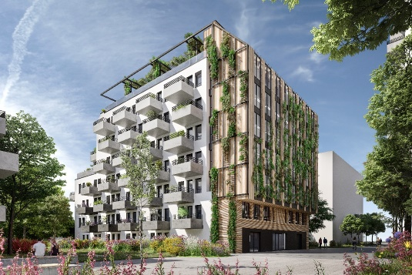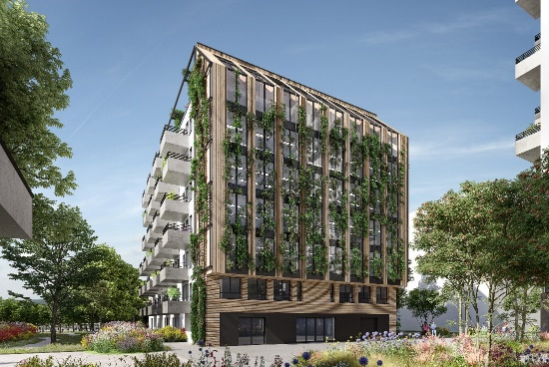

About S+B Gruppe:
S+B Gruppe AG, a privately-owned property developer with offices in Bucharest, Prague, Vienna and Warsaw, has been executing complex projects for over 35 years, acting as both an investor and general contractor. The team, headed by Managing Director Reinhard Schertler and Viennese general planner Alfred Michael Beck, together with the long-standing board members Wolfdieter Jarisch for Austria and Franz Paul Bauer for the CEE region and the two board members Edmund Völker and Wolfgang Eder for finances and accounting, specialises in the planning, construction management, commercial management and marketing of top-quality construction projects. A number of major developments are currently underway in Central and Eastern Europe. The combination of local on-site staff and international expertise is the key to S+B’s success. To date, the Group has invested more than EUR 6.2 billion in developing a total of 1,200,000 sqm of usable space.
www.sb-gruppe.at

About C&P Immobilien AG:
C&P develops, sells, rents and manages real estate projects. With over 7.000 apartments sold and a current project development pipeline of over € 1,6 billion, C&P Immobilien AG is the Austrian market leader for investor properties in the private customer segment. Currently, 184 highly committed employees work at 6 locations in Graz, Vienna, Klagenfurt, Berlin, Munich and Dubai. The company's own asset and existing property portfolio exceeds € 87 million. As a full-service partner, we offer an all-round carefree service: From development, construction, sales and consulting to the point at which you want to rent out your apartment and beyond, all administrative tasks and threads come together at C&P.
Our property investment product has already proven to be a great success, but we also have new products in the pipeline. In addition to innovative living concepts, we also plan to develop cutting-edge work concepts.
www.cp-ag.at

About BNP Paribas Real Estate Investment Management
BNP Paribas REIM, a business line of BNP Paribas Real Estate, provides a wide range of real estate funds and investment solutions for investors, based on strong convictions. Deeply European, we have a close understanding of local markets. With our 360 employees, we care for assets as we care for living beings, aiming to build a better living environment for our 200+ institutional investors and 140.000+ private investors. We believe in ESG to reconcile social, environmental and financial performance. We apply innovation in order to better adapt to the risks and opportunities of today and tomorrow.
At the beginning of 2021, BNP Paribas REIM manages € 29,7 billion of living European assets on behalf of institutional and private investors.
BNP Paribas Real Estate Investment Management is composed of regulated entities in the following countries: France, BNP Paribas Real Estate Investment Management S.A.; Italy, BNP Paribas Real Estate Investment Management Italy SGR; Germany, BNP Paribas Real Estate Investment Management Germany GmbH; UK, BNP Paribas Real Estate Investment Management UK Limited; Luxembourg, BNP Paribas Real Estate Investment Management Luxembourg S.A.
Each of the legal entities responsible for offering products or services to their customers is referred to in the product documentation, contracts and relates information.
www.reim.bnpparibas.com/de

Rückfragen an:
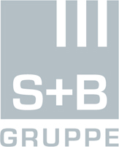
S+B Gruppe AG C&P Immobilien AG BNP Paribas REIM Germany
Mag. Andrea Jarisch Michael Thier Melanie Engel
andrea.jarisch@sb-gruppe.at m.thier@cp-ag.at melanie.engel@bnpparibas.com
Tel: +43 1 7130650 5019 Tel: +43 5 0316 132 10 Tel. +49 40-348 48-443

