Widok Towers
Warsaw, JULY 2021
Widok Towers welcomes new tenant
The Investor Commerz Real has concluded a long-term lease agreement with the Warsaw City Hall. The office space of approximately 12 000 sqm will accommodate individual offices of the City Hall and is spread over 10 floors of the Widok Towers office and retail tower developed by S+B Gruppe AG.
The office space leased by the Warsaw City Hall features state of the art technical solutions and meets all applicable legal requirements regarding fire safety, occupational health as well as safety and accessibility for people with disabilities. The building is equipped with touchless access control in the main lobby, anti Covid-19 hand sanitizers, several terraces partly even with green areas and 100% fresh-air ventilation with F7 filters throughout the building in addition to openable windows. The entire building has been environmentally certified with regard to the safety of use and, most importantly, meets the highest sanitary and fire safety standards.
Mrs. Izabella Kieler, Head of Leasing and Marketing, is now pleased to be able to allocate the other interested tenants to the remaining available floors. Mr. Johannes Bauer, Head of S+B Poland, confirms that it is the greatest reward for any real estate developer that a city hall has chosen its building as the new headquarters.
Widok Towers is a 27-storey building that offers 34 779 sqm of space, perfectly suited for retail and offices. The new landmark rises tall at the foot of Rotunda at the junction of Jerozolimskie and Marszałkowska Streets, or right on top of the Metro Station Centrum. This vibrant location is packed with shops, restaurants, and cafés.
Additional information
Contact Web
Vienna Warsaw Widok Towers online
S+B Gruppe AG S+B Plan & Bau Warschau Sp. z o.o. www.widoktowers.com
Löwengasse 47 ul. Królewska 18
1030 Wien 00-103 Warszawa 360° Online Showroom
+43 / 1 / 713 06 50-0 +48 / 22 / 375 30 11 widoktowers.com/en/show-floor
wien@sb-gruppe.at warszawa@sb-gruppe.at
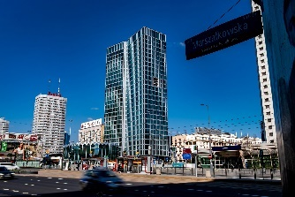
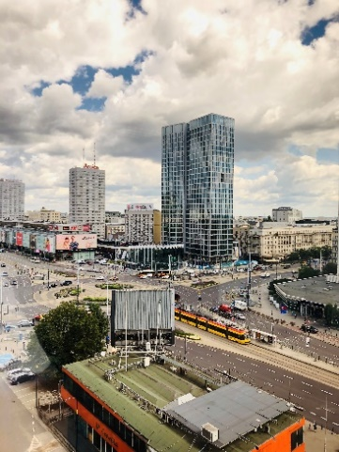
Images
The images for use in the article can be downloaded
from this link

